Glow Conference 2020

Information for oral presentations

- Standard oral presentation
- Pecha Kucha
- Soapbox
- Poster presentation with discussion

Congratulations on your acceptance to present your work at the 2020 GLOW Conference on 10th & 11th September 2020, hosted by the Sanyu Research Unit at the University of Liverpool, and the Centre for Maternal and Newborn Health at Liverpool School of Tropical Medicine.

Please note that all presentations must be submitted in advance of the conference, by 12.00 GMT on 31st August 2020. When you have uploaded a video, please email glowconference1@gmail.com to inform us. Power point posters for the posters with discussion should be emailed as a PDF to glowconference1@gmail.com, by 12.00 GMT on 31st August.

There are several different formats of presentation, so please be careful to adhere to the guidance strictly, for the correct style of presentation.

Abstract themes:
- Implementation science, and general global obstetrics/gynaecology
- Respectful Care, and Year of the Nurse and the Midwife

Presentation formats:
There are four different formats of presentation, and each presenter will only undertake one presentation. The email from the conference organiser will highlight which style of presentation you have been asked to submit.

- ​Standard 10 minute oral presentation
- Pecha Kucha style presentation
- Soapbox
- Poster presentation with discussion

General instructions –
- These sessions will all be pre-recorded videos (see detailed instructions attached) which must be submitted by 31st August.
- Each presentation has a different format, so please ensure you know which type of presentation you have been asked to submit and follow the guidelines.
- Ensure appropriate referencing/copyright is used for all images.
- Please ensure that consent is taken for any photos to be shared online, especially those of patients. Please note that any images which include humans must have consent for the graphic to be used in the public domain.
- Ensure the layout of the slides is similar throughout.
- Graphs, figures and flow charts are often a clear way to present data. Tables can be difficult to read.
- Please ensure your speech is slow and clear and that the sound on the video is of high quality. (Please see top tips for further details on how to create a high quality video.)
- Please save your video in the format Surname.ppt so that we know which abstract to link it to.
- Once you have finished, please upload your video to:
https://sflgroupuk.sharepoint.com/:f:/s/production/ElkWtz-R97pGlYdHbCc0oF8BRLvWIIE6M0g-pv4NM3dLWQ?e=ueQoq0

- All videos will be reviewed by the GLOW organising team, and you may be contacted to re-submit your video if the quality is below the required standard.

Oral presentations
Format - 10 minute pre-recorded video presentation with PowerPoint slides (followed by a 5 live minute Q&A)

The presentation will be pre-recorded and submitted to the GLOW conference storage space prior to the conference. Recordings should last for 10 minutes and this timing must not be exceeded. PowerPoint slides should be used, usually up to 10 slides, ensuring the font is large enough to read and the content is not too detailed on screen.

At the conference, the presenters must be available for live Q&A 30 minutes prior to the allocated point in the timetable. We will contact you closer to the conference date to confirm the timings, dates etc and confirm the time of a very short test call the day prior to the conference.
- Implementation science – Thursday 10th September, 14.00-14.50 GMT
- Respectful care and the year of the nurse midwife– Friday 11th September, 15.10 – 16.00 GMT

Pecha Kucha
Format - Pecha Kucha style presentation (video presentation to power point slides, 20 slides with pictures only excluding the title slide, 20 seconds maximum on each slide - see www.pechakucha.com).

The presentation will be pre-recorded and submitted to the GLOW conference storage space prior to the conference. The presenters are advised to practice their presentation and set an automatic timer, to change the slides every 20 seconds.

The presenters should be available for online text questions via the app between 17.00 and 17.50 on Thursday 10th September. There will be live polling and the best presentation will be highlighted at the end of all of the presentations.

Soapbox
Format - Video recorded 3 minute discussion on a global health topic that you feel is relevant for this conference. It may or may not include research findings or opinions only, as the soapboxes are aimed to provoke thought and discussion. No slides will be used, just the presenter talking to the camera.

These pre-recorded videos will be played at various points throughout the conference, and available on the app and website. Please follow the general advice PDF for video presentations to ensure high quality audio and images.

Poster presentation with discussion
Format – Standard one slide poster presentation, with 5 minute recorded presentation and live Q&A questions in the chat box on the app and via the website.

The presentation should be prepared as a typically displayed poster (instructions below) along with a 5 minute video/audio recording explaining the poster and live Q&A in the chat box. The audio file should be created separately and the audio file and PowerPoint slide submitted separately. Please ensure that the file titles are the same so that the correct audio file is put with the correct slide.

Presenters must be available for questions on the app and online at the allocated time.

- Implementation science/general – Thursday 10th September, 11.20-11.50 GMT
- Respectful care and the year of the nurse midwife– Friday 11th September, 11.20 – 11.50 GMT
Please note that all poster presentations must be submitted in advance of the conference, by 12.00 on 31st August 2020. Posters should be emailed as a PDF to glowconference1@gmail.com, in the format outlined below.

Poster which are not in the appropriate format will be returned to authors.

General instructions – posters

- All posters should be made on a single slide of PowerPoint in a landscape orientation. Ideally this would be A0 or A4 but you can use any size (as viewers will be able to enlarge the poster on their screens). Remember, however, not to have the text too small otherwise it will make it difficult to read.
- Please convert the poster to a pdf before submitting. If you do not do this, the formatting may be lost on the screen.
- The maximum file size for uploading is 10MB.
- Please save your poster in the format Surname.pdf so that we know which abstract to link it to.
- Please remember to include diagrams and visuals to make the poster look appealing, but also legible.
- Avoid long sentences and try to make all text succinct.
- Avoid detailed tables and try to present data as graphs or flow charts.
- Ensure appropriate referencing/copyright is used for all images and consent is taken for any photos.

Please note that for the poster presentations with discussion, the website/app will show a “still” of the image of your poster, with an audio recording of your voice explaining it. Your poster will be presented in the exact same format as a typical poster, but you will also have the opportunity to share your research verbally. The PowerPoint poster must be submitted via email as above, whilst the audio must be submitted via the sharepoint site.

Top tips for making videos

This is a simple how to guide with top tips to give your presentation and make your video look great.

Top Tips:

- Stay within your time limits. Digital minutes are not the same as real minutes. Peoples concentration time is less online.
- Make sure your camera or video device is the correct way around. Phones must be in landscape.
- Keep camera at eye level.
- Make sure you have enough front light.
- Try to minimise the background noise in the room (examples include traffic, kettle and doorbell.)
- If you are using powerpoint, make sure the slides are not too wordy and the font is big enough. Remember some people may be viewing the event on a tablet or phone.
- De clutter the background.
- When you get to the end, listen back and make sure you are happy, and it looks great.
- If you have included any videos or images, make sure you have the relevant copyright approval. (including references)
- Please email your session co-ordinator once you have uploaded your video.

Camera

There are many options on the market.

Laptop/ webcam
If you are using the webcam built into your laptop, make sure it is at eye level. If it is on the desk in front of you, raise it up on some books.

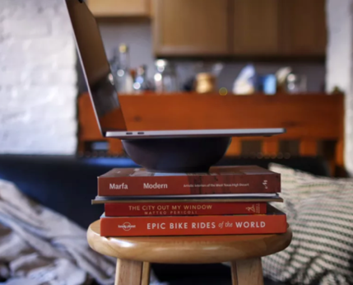

Phone/ Mobile Device
If you’re using your phone (these can make fantastic cameras) make sure it is mounted on a clamp or stand so it doesn’t move during your recording. When you record make sure your phone is in landscape, so the image is the same shape as your TV rather than a long thin box.

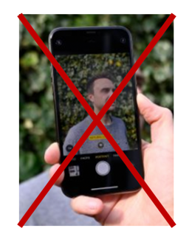
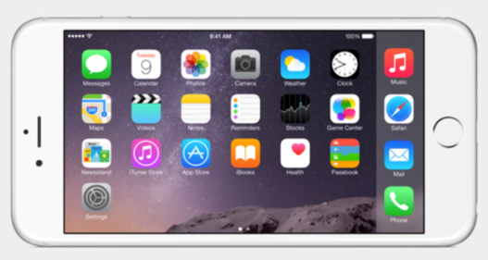

Other external Cameras

Other external cameras/ DSLR and others will also work well. Just mount them on a stand or tripod and look into the lens. Make sure this is mounted at or above eye level.

Please present directly to the Camera. Imagine they are sitting in front of you and you are looking them in the eye.
Your videos need to be 720p minimum quality.

Lighting

This is where most people seem to go wrong.

If you just turn on the usual overhead lights in your room, it will probably cast a shadow onto your face. People want to see you and your face. ☺

We need to balance 2 types of light. Front light and back light.

Front (or key) light.

This is light that you shine in your face. This could be a simple lamp you have at home.

Back light.

This is to make you stand out from your background.

Person with ceiling lights turned on.

Person with front light (just a home anglepoise.)

The Background

This is key to your video.

You need to choose somewhere plain and not too cluttered. Try not to be in front of a window as light will stream in and wash you out. Think about how you can tidy up the background.

Audio

This is one of the most key things. People want to hear what you have to say clearly. There are many approaches to this. If you are using your laptop. You could get an external USB microphone. The internal microphone is generally not incredible but can work as a last resort. If you use this make sure you are close to your laptop for the recording.

Bluetooth earphones such as Apple Airpods are great for this as they are quite small and subtle in your ears.

Please try to stop any other noises etc. Close windows to stop traffic noises and try to keep other distractions limited.

What should I name my video?

Please name your video in the format. Surname_Day1_Session 1 etc

Once you have finished. Please upload your video to:

https://sflgroupuk.sharepoint.com/:f:/s/production/ElkWtz-R97pGlYdHbCc0oF8BRLvWIIE6M0g-pv4NM3dLWQ?e=ueQoq0

Frequently asked questions –

GLOW 2020

Do I need to register at the conference if I am submitting a poster/presentation?
Yes, submitting your work does not constitute registering for the conference. This is very simple and is totally free. This can be done from the GLOW website https://www.glowconference.org.

Can I make changes to my abstract?
Yes, until 31st August 12.00 GMT, when all presentations and posters should be submitted.

Are there any deadlines that I need to adhere to?
All posters and presentation recordings need to be submitted by 31st August 12.00 GMT. If you have exceptional circumstances and are not able to meet this deadline, please email us glowconference1@gmail.com.

Why do I need to submit my poster/presentation so far in advance of the conference?
The posters and presentations need to be checked and uploaded onto the app and website, prior to the conference. We are expecting over 100 posters and over 50 videos to be submitted, therefore the conference organising team needs to ensure the audio/visuals are of adequate quality.

Will I speak live at the conference?
The questions and answers for the oral presentations will be live. The questions and answers for the petcka kucha will be via text chat on the app/website (more information to follow.)

When do I need to be available?
Whilst your presentation is being shared online, it is necessary that you are available to respond to questions as they arise during the presentations. This will give you the best change of ensuring your research is understood and widely disseminated.

When and where can I submit my poster?
Please email glowconference1@gmail.com by midday on 31st August 2020.

When and where can I submit my oral presentation?
Please upload your presentation to the shared site, as per instructions in the PDF.

Can I change the presenting author?
Yes, until submission close on 31st August 2020.

Where can I find out more information?
More information will be added to the GLOW website https://www.glowconference.org in due course and will also be available via the conference app. If these instructions do not answer your questions, please check the website or email us at glowconference1@gmail.com.

What will happen after the conference?
The presentations and posters will be available on the conference app for one year after the conference. All videos will be shared on the GLOW conference’s You tube channel.

